**Data analysis-B**

Performing a general data analysis

**Importing libraries:**

1. First of all I imported all the libraries into the jupyter notebook to perform analysis.

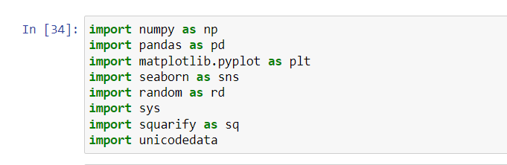

1. second step by using pandas library I read the csv into data frame.

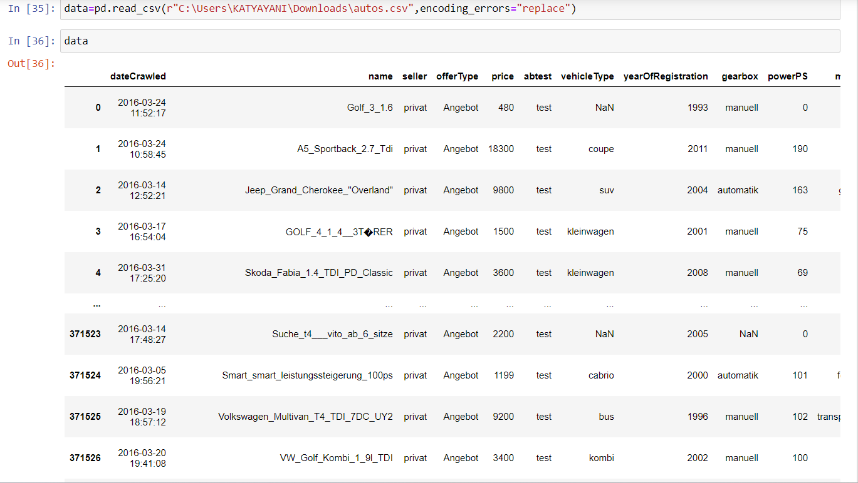

1. by converting csv file into data frame I can see perfectly how many columns is present in data set.
2. by knowing how many colums and rows presented in data we can perform analysis easily.
3. by seeing the below picture we can known that how many rows and columns present in data set.

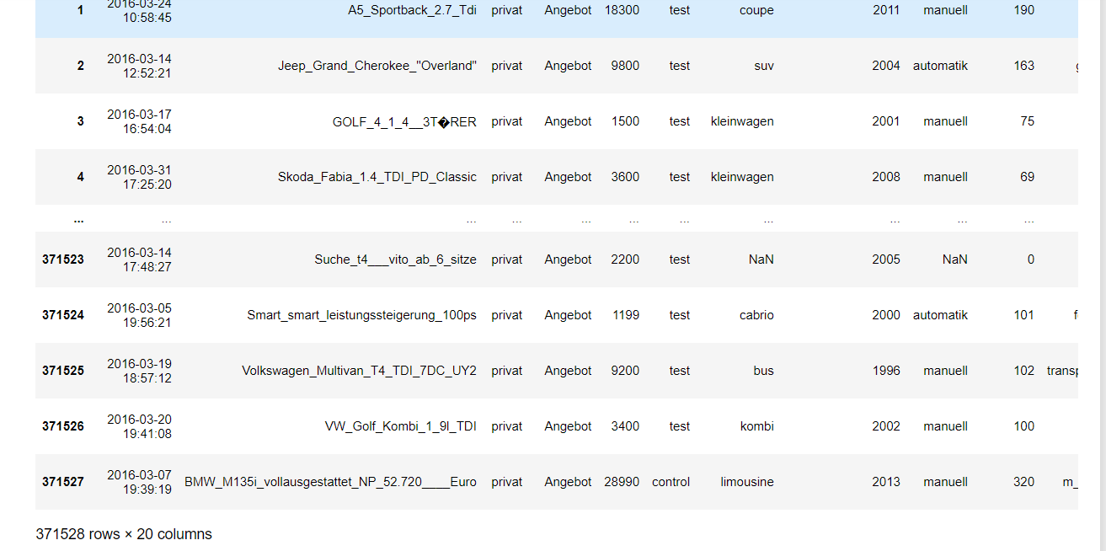

1. By seeing the data set I founded that The data set has 371528 data points. This data set is about the different vehicles available for sale.the data set has total 20 columns in that 7 are int64 data type and remaining 13 has object type.It takes total 56.7+ mb memory space.

**#1) Can you tell me No of Vehicles by Brand Available on ebay for sale with the help of visualization**

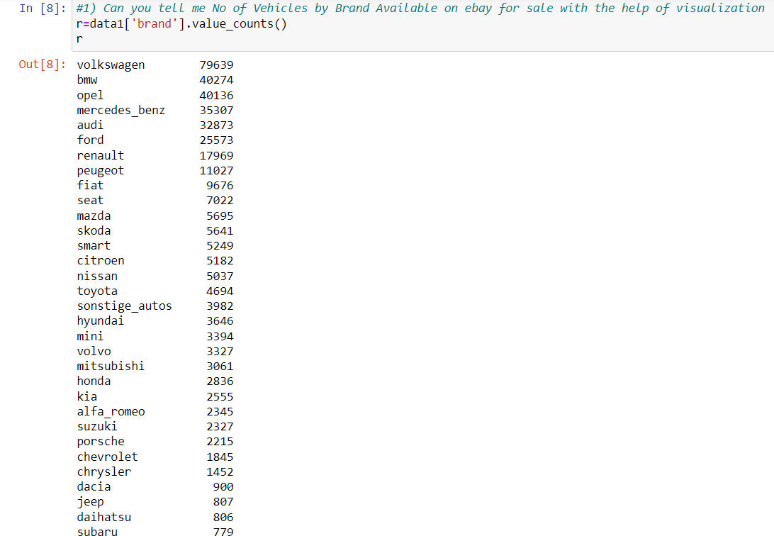

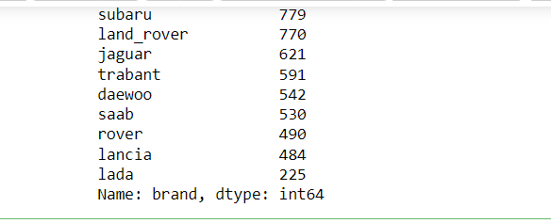

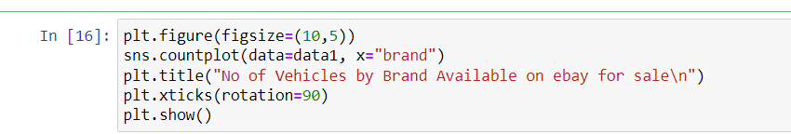

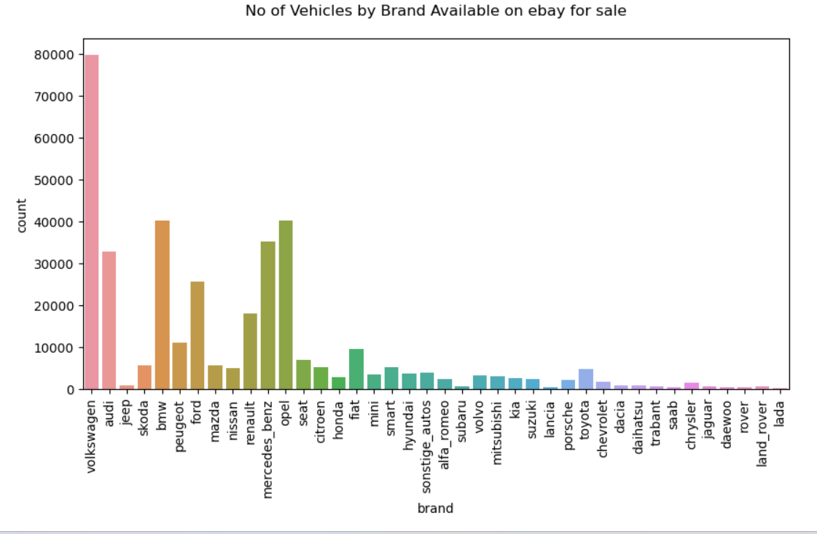

* By using the below code I’ll show the visualization of me no.of vehicles by brand available on ebay for sale.
* From the above plot I can tell that Volkswagen brand has more number of vehicle available on ebay for sale and the count is 79640.
* And the brand lada have less number of vehicles available on ebay for sale with the count of 225.

***#2. What is the Average price for vehicles based on the type of vehicle as well as on the type of gearbox.Explain me with both numerical and visualization analysis***

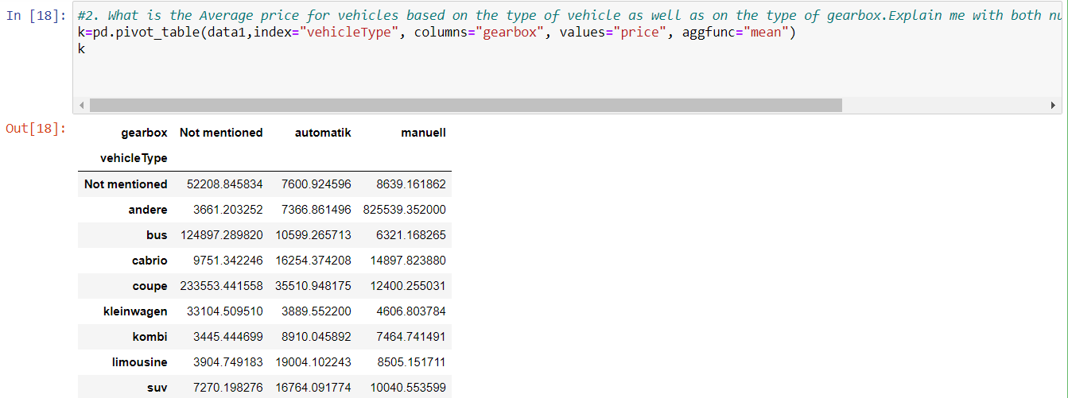

* For average price for vehicles based on vehicle type.
* To find the average price for vehicles by type I used groupby() function. From that group by data I have created a new data frame named data_vehicles.
* And then I plot a bar plot on that.

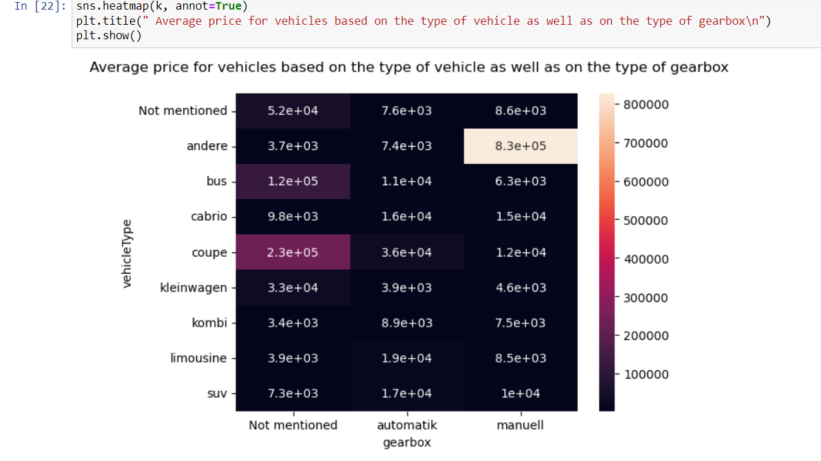

* From the above plot the average price for vehicles based on vehicle type is high for andere with the 677329.
* And kleinwagen ha less price with 5695.
* b.For average price for vehicles based on gearbox type.
* To find the average price for vehicles by gearbox type I used groupby() function. From that group by data I have created a new data frame named data_gearbox.
* from the above plot I can tell that the vehicles which don’t have any type has more average price when compared to others with 44019.
* And automatic has less average price with 15146.

**#3. What is the marginal probability of private seller**

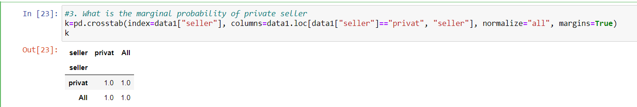

* From that the marginal probability of private seller is 0.99.

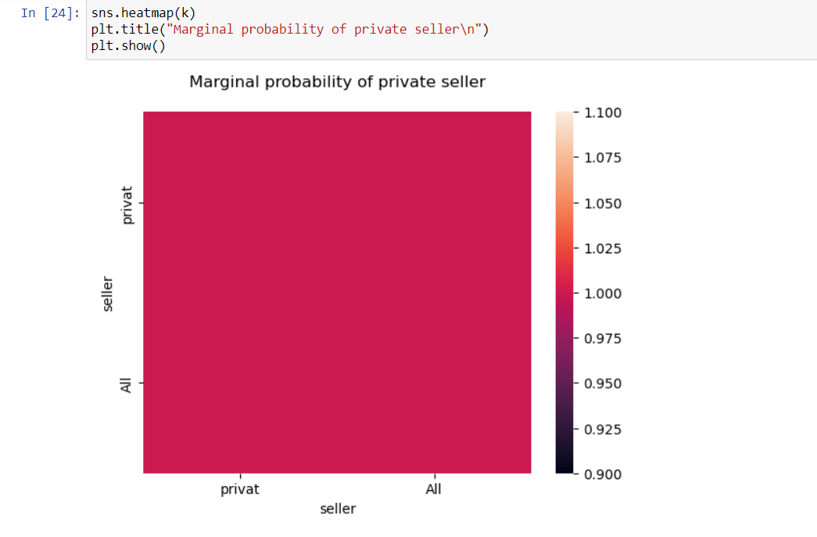

**\*\*\*\*\*\*\*\*\*\*\*\*\*\*\*\*\*\*\*\*\*\*\*\*\*\*\*\*\*\*END\*\*\*\*\*\*\*\*\*\*\*\*\*\*\*\*\*\*\*\*\*\*\*\*\*\*\*\*\*\*\*\*\*\*\*\*\*\*\*\*\*\*\*\*\*\*\*\*\*\***